# Research Process in RTOS

## Definition.

A process is basically a program in execution of instance of the program execution. The execution of a process must progress in a sequential fashion.

* Process is not as same as program code but a lot more than it.
* A process is an ‘active’ entity as opposed to program which is considered to be a ‘passive’ entity.
* Attributes help by process include hardware state, memory, CPU etc.

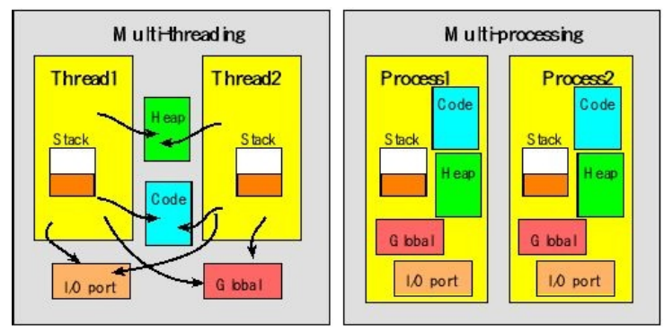

Multiple parts:

* The program code, also called **text section**.
* Current activity including **program counter**, and **processor registers**.
* **Stack section** containing temporary data
  + Function parameters, return addresses, and local variables.
* **Data section** containing global variables.
* **Heap section** containing memory dynamically allocated during run time.

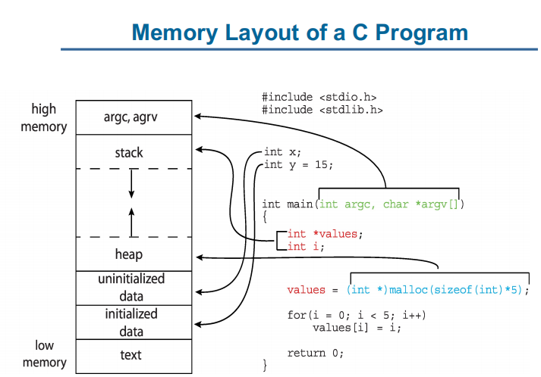

## Booting process.

Now we understand the basic concepts, lets see how they work in booting time.

1. Power On Reset
2. Execute boot loader in boot ROM
3. Processor read BOOT pins to determine the booting mode. For example if BOOT0 is 0, Main Flash memory is mapped into Alias space from address 0x00000000
4. Next processor fetch the first word from memory space. As the beginning of the memory space contains the vector table, and the first word in the vector table is the initial value for the Main Stack Pointer (MSP). Processor set up the MSP after that.
5. Processor continues read the next word in vector table, now is reset vector, which contains the Reset_Handler() function address.
6. Reset_Handler() function address is moved into Program Counter (PC) and processor starts running Reset_Handler()
7. Inside Reset_Handler(), System_Init( ) function will be run first, follow is our application (main())

=> việc ánh xạ chúng ta sử dụng thanh ghi **SCB->VTOR = MEMORY_BASE**

1. 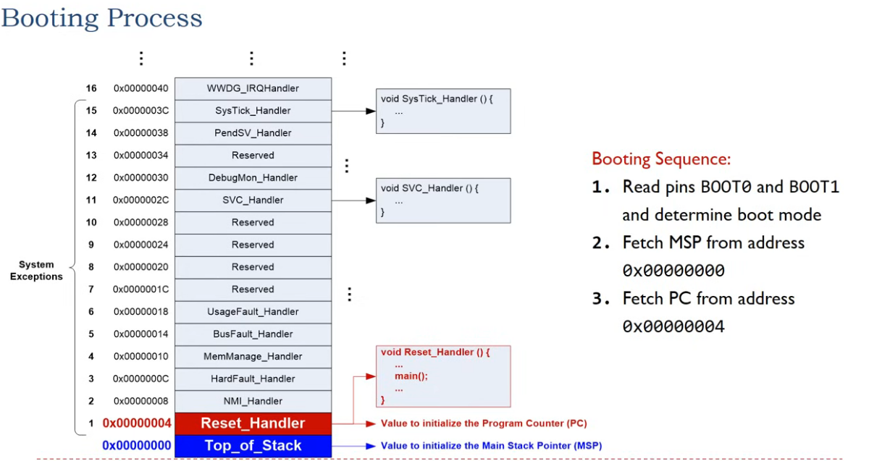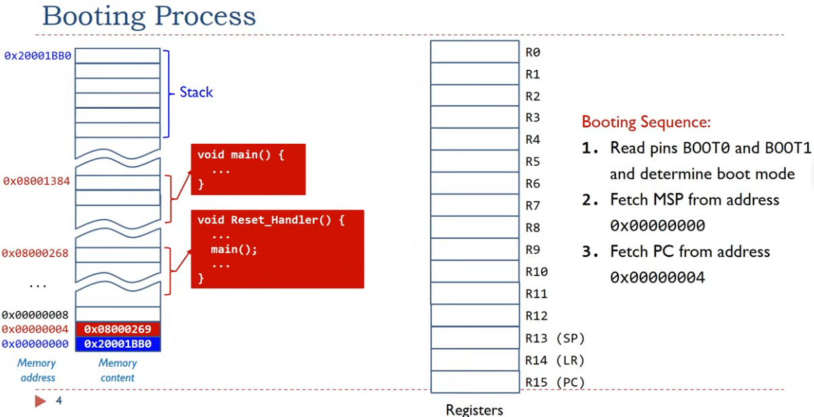

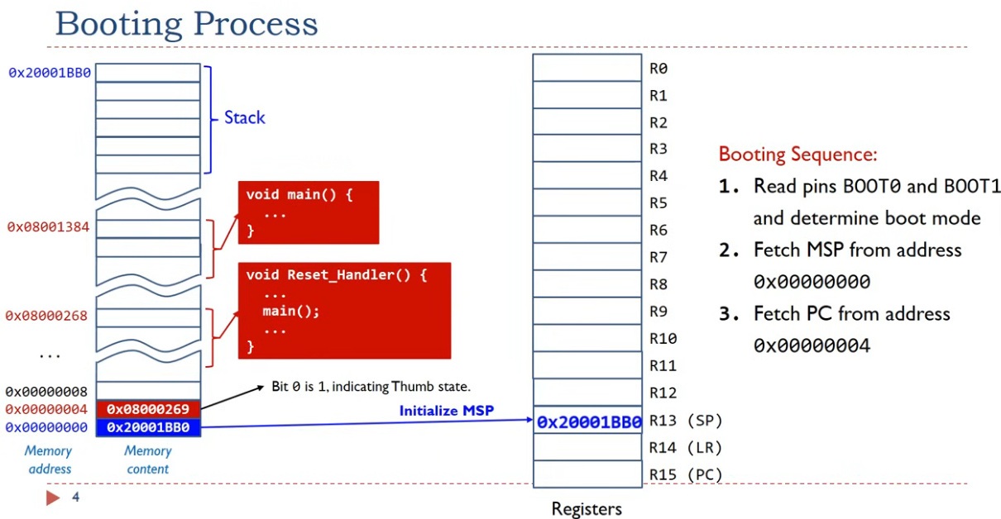

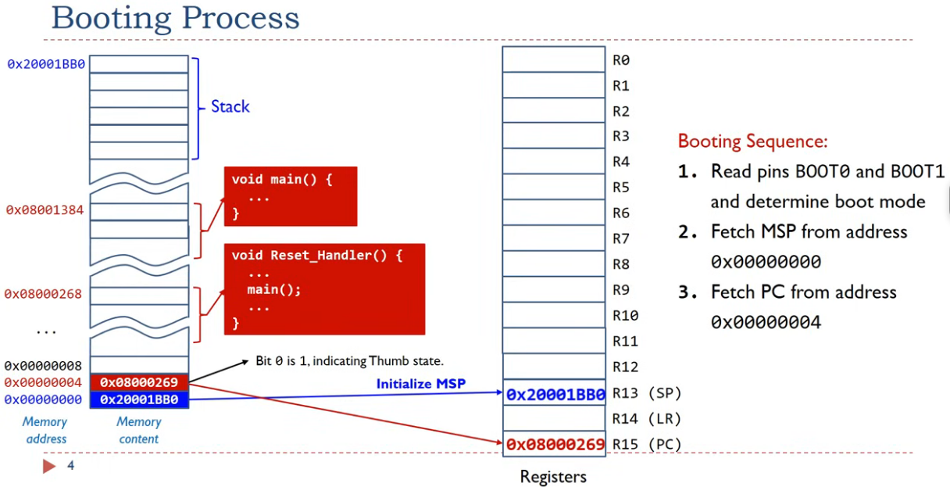

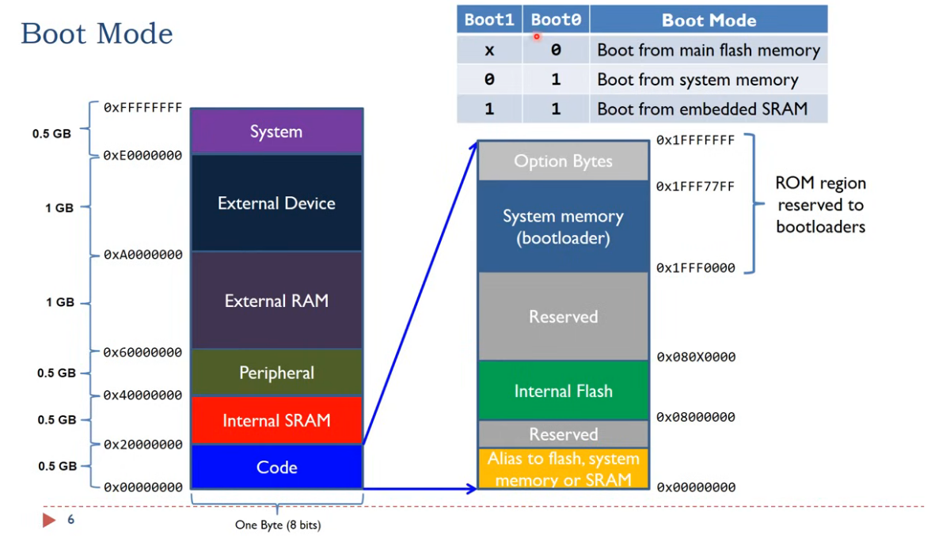

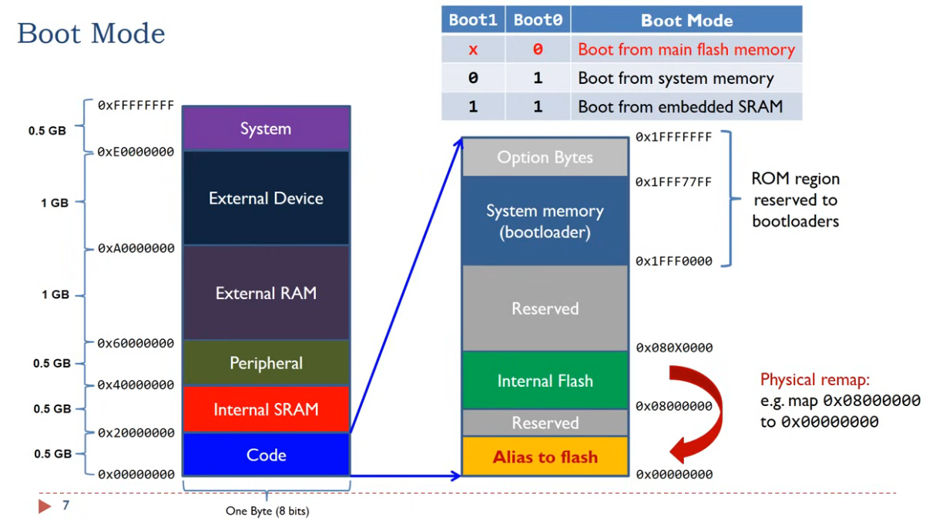

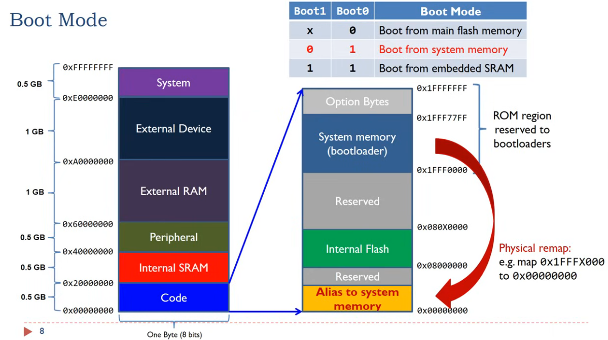

## Inter-Process Communication (IPC)

Process within a system may be independent or cooperating

* Independent process does not share data with any other processes executing in the system.
* Cooperating process can affect or be affected by other processes including sharing data.

Reasons for cooperating processes:

* Information sharing.
* Computation speed - up.
* Modularity.
* Convenience.

=> Cooperating processes need Inter-Process communication (IPC).

Tow models of IPC:

* Shared memory.
* Message passing. (mailbox and FIFO queue **ĐÃ HỌC** trong phần lý thuyết)

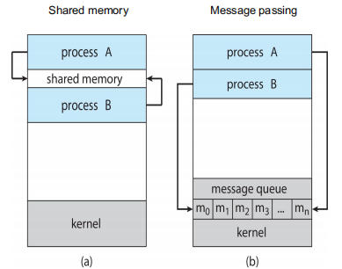

## Question:

1, Chưa hiểu rõ cách dùng và ngữ cảnh sử dụng MSP và PSP ?

2, Chưa hiểu cơ chế share memorry ?

## Present:

1/ Thành phần process

2/Khởi động process

a/ Memorry layout.

b/ Vector table.

c/ Quá trình boot. (reset handler, thanh ghi để alias… )

d/

<https://www.iar.com/knowledge/learn/programming/rtos-detecting-stack-overflows-part-2/>